

**Lab No. 07**

Mehran University of Engineering and Technology Shaheed Zulfiqar Ali Bhutto Campus, Khairpur Mir’s Department of Software Engineering

**Course: Operating System SW-225 (Practical) - Instructor: Engr. Shamshad Naveed**

Objective: Installing a desktop sharing environment using SSH

|  |  |  |  |  |
| --- | --- | --- | --- | --- |
| **Name:** | **Muhammad Saleem** | **Roll Number:** | | **K20SW033** |
| **Score:** | **Signature:** | **Date:** | **04/10/2022** | |

|  |  |  |  |  |  |  |  |
| --- | --- | --- | --- | --- | --- | --- | --- |
| **LAB PERFORMANCE INDICATOR** | SUBJECT KNOWLEDGE | DATA ANALYSIS AND INTERPRETATION | ABILITY TO CONDUCT EXPERIMENT | PRESENTATION | CALCULATION AND CODING | OBSERVATION  /RESULTS | SCORE |
|  |  |  |  |  |  |  |  |

Exercise:

**Task 1.** Create a desktop sharing environment using **“TeamViewer”**

**Step 01.** Search on browser “TeamViewer” and click on below link [https://www.teamviewer.com](https://www.teamviewer.com/)

**Step 02.** Select your bit and download it

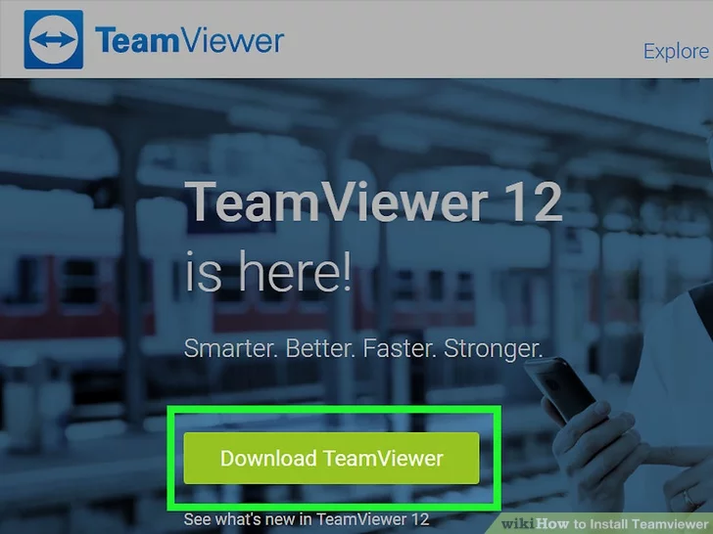

**Step 03.** Click on downloaded setup and install it in your system

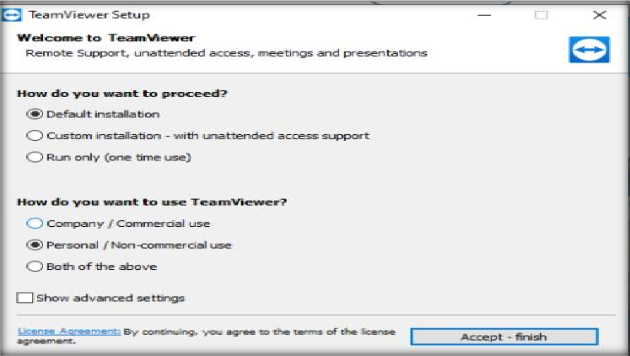

**Step 04.** Process of installation have been started

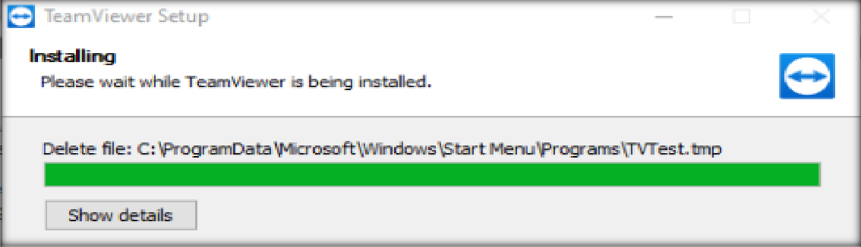

**Step 05.** Open TeamViewer, Select Remote Control and then enter Partner Id.

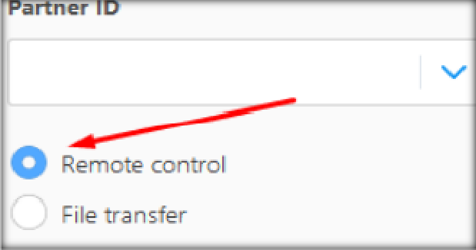

**Step 6.** Here is PC 1 ID and Password

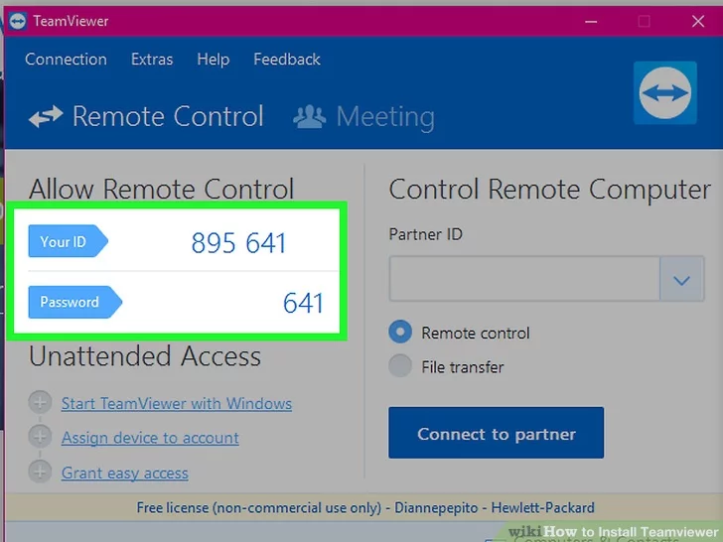

**Step 7.** Here is PC 2 ID and Password

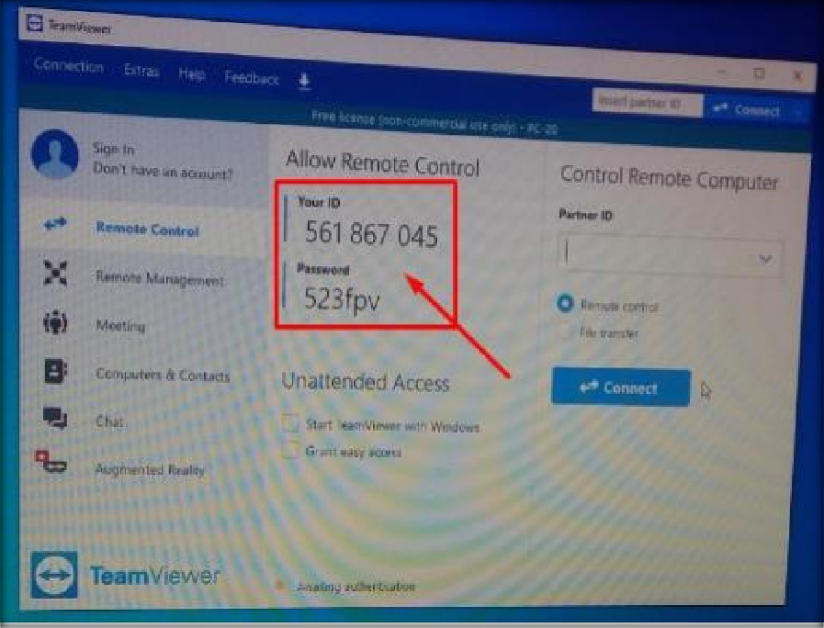

**Step 8.** After giving PC 1 ID and password to PC 2 and select connect Here is PC 1 Screen

which is accessed by PC2.

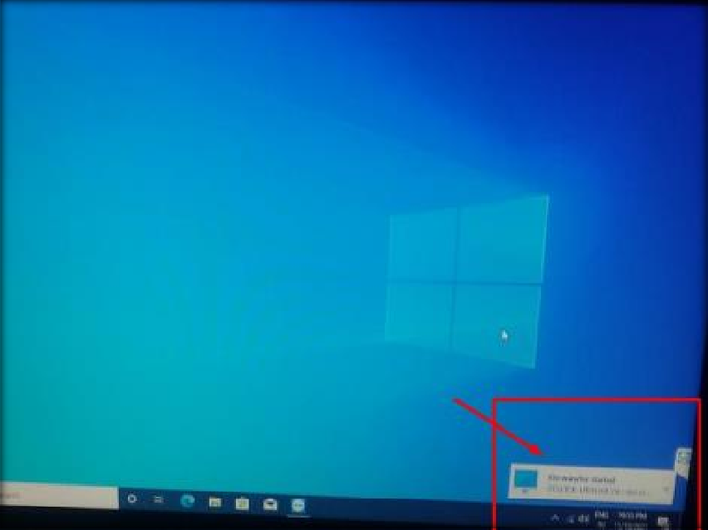

# “Your partner’s PC/Laptop is accessible to you. You can control this now”

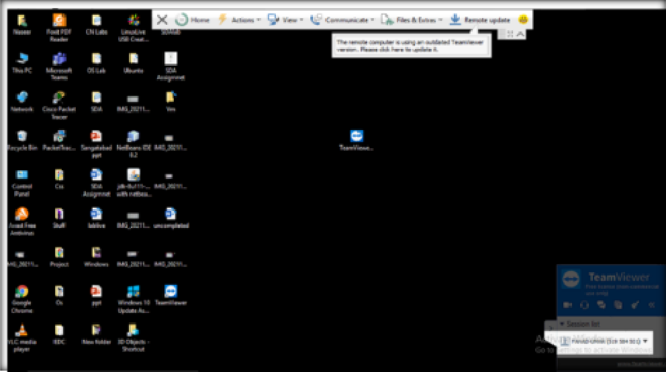

**Task 2.** Give more examples of Platforms to do Remote Screen Sharing for Windows and

explain them in detail.

**Answer:** There are several platforms for desktop sharing some of them are given below.

# GoToMeeting

1. **Chrome Remote Desktop**

# AeroAdmin

1. **Lite Manager**

# AnyDesk

1. **Remote Utilities**

# Mikogo

1. **ShowMyPC**

# MingleView

1. **SkyFex**

Now, we will see introduction of these platforms

# 1. GoToMeeting



GoToMeeting is a web conferencing software by GoTo. It is an online meeting, desktop sharing, and video conferencing software package that enables the user to meet with other computer users, customers, clients or colleagues via the Internet in real time.

**2. Chrome Remote Desktop**

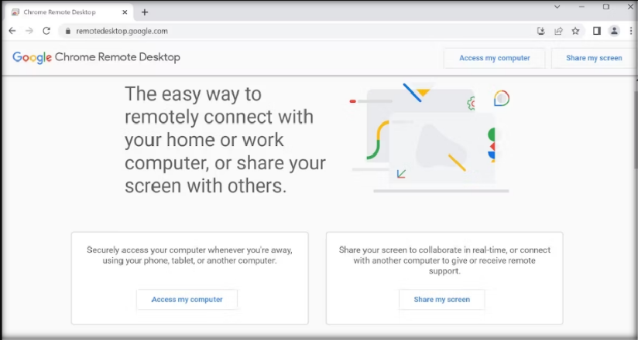

Chrome Remote Desktop has one glaring drawback—both computers need to have the Chrome browser installed. If you use an alternative browser, you should look elsewhere.

However, if you use Chrome and you're looking for an easy-to-set-up, no-frills remote access tool, you will struggle to find a better option. Google has aimed the software at home users who need to share computer screens for some quick troubleshooting or file access.

**3. AeroAdmin**

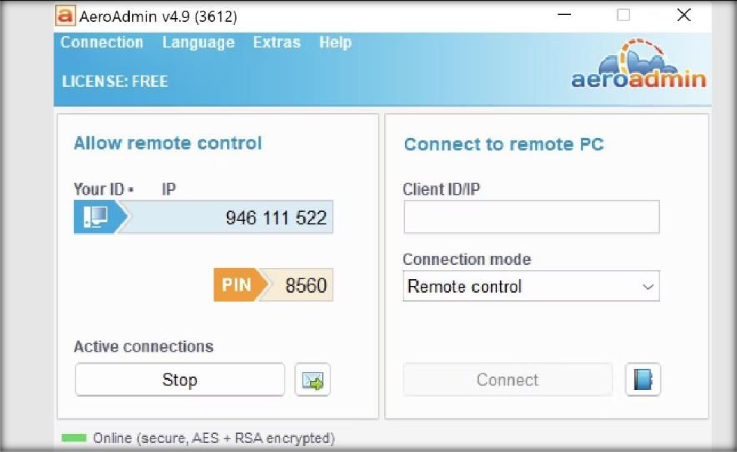

The development team behind AeroAdmin clearly took inspiration from TeamViewer; the way the app works, and the on-screen visuals are strikingly similar.

Unlike TeamViewer, however, it does not require any installation. You just need to run the 2 MB EXE file and follow the on-screen instructions. It means you can keep a copy on your USB flash drive and instantly provide remote access to any machine you are sitting in front of. You can make a connection using your computer's IP address or by sharing the automatically generated passcode.

**4. Lite Manager**

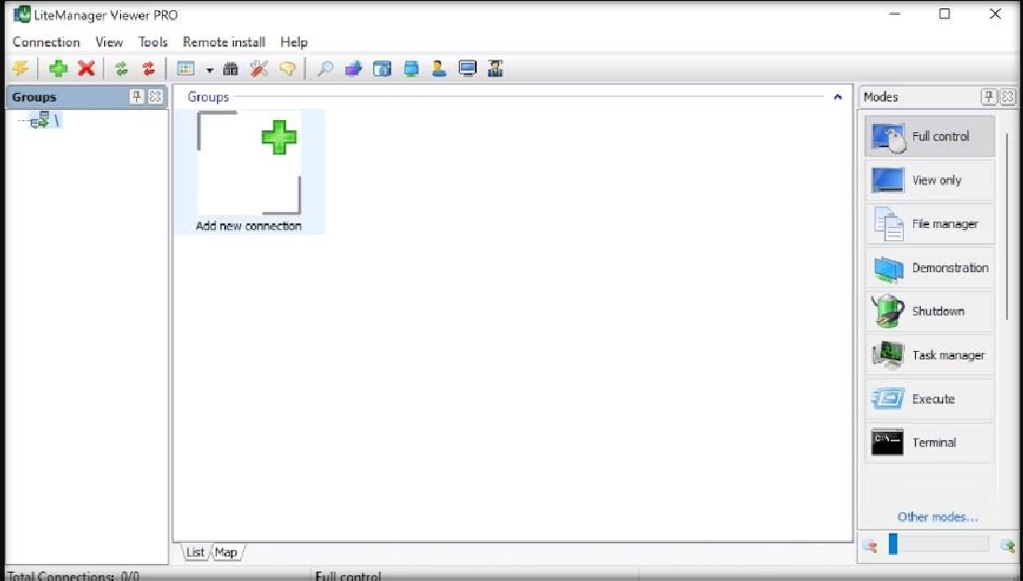

Lite Manager is an under-appreciated program that offers many of the same features as some of the expensive paid tools. Of course, the basics like file transfer and text chat are covered— but here are some of the coolest advanced features:

# RDP integration

* **Screen recorder**

# Remote installation of screen-sharing software

* **Network mapping**

# IP filtering

* **Registry editor**

# Cascade connections

* **30 connected computers**

A paid version is available ($10 per license), but for most people it's unnecessary.

**5. AnyDesk**

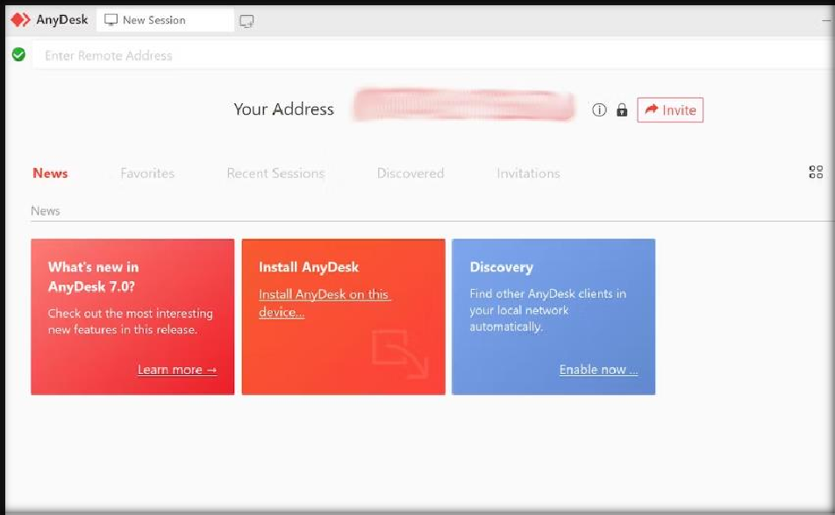

AnyDesk can be run as either a portable program or a desktop app. Connecting the two apps is simple; the client just needs the host's AnyDesk address or an alias.

There's also an option to set up unattended access. It's great if you want to access your files remotely without a person's physically using your other machine.

Other features include an adjustable slider that balances connection quality with connection speed, clipboard syncing, remote session recording, and cross-computer keyboard shortcuts.

**6. Remote Utilities**

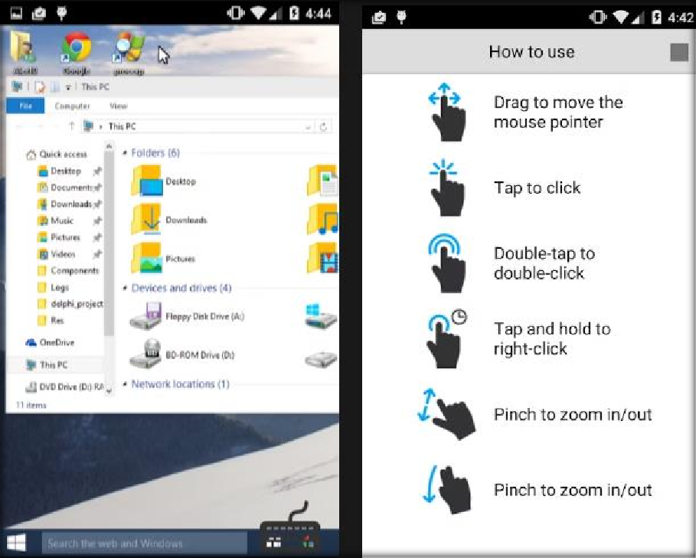

The app has both pros and cons. For example, it can bypass firewalls and NAT devices and supports connection to many computers at the same time. But on the downside, it only supports Windows machines.

**7. Mikogo**

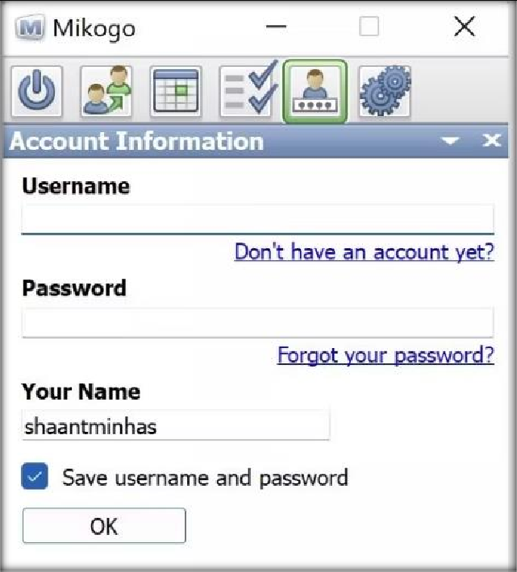

Mikogo lets you share your desktop and remotely access another user's PC.

It has a live chat window and supports file transfers. There's also a cool feature that prevents certain apps from sharing their content; it will stop you from accidentally displaying sensitive information to all the participants.

**8. ShowMyPC**

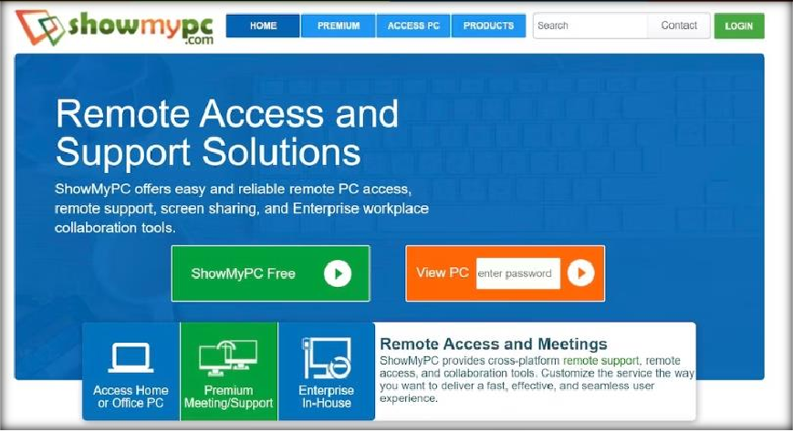

ShowMyPC is focused on screen sharing. With a fairly simple user interface and Windows, Mac, and Linux compatibility, it makes a solid choice if all you're looking for is to share your screen.

There is a free version and a paid version. The free version of the app can be downloaded from the site. You do not need to make an account to start using it and you don't even need to install it on your machine—the app is portable.

**9. MingleView**

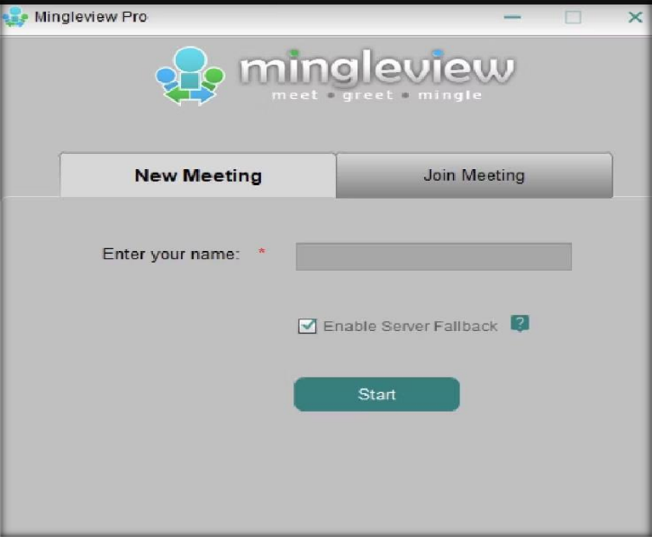

Mingle View is a Windows-based free screen-sharing software program that has no premium package upgrade.

The app lacks the large development budget of some of its competitors, but still managed to be one of the first free desktop sharing apps that allowed unlimited participants and unlimited meeting hosting.

If you don't want to download the desktop app, you can view (but not control) another person's screen via the web app.

1. **SkyFex**

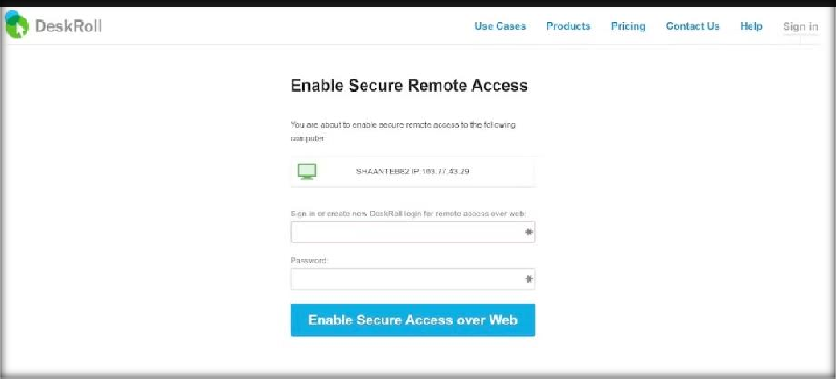

SkyFex is an online remote access service. That means it doesn't require a download—it's entirely browser-based. It also means that SkyFex is accessible on all platforms, making it a nice choice for those who are looking for an easy tool to use to help clients or even just friends.

The app secures all communications with 256-bit SSL encryption and proprietary protection methods, and it will work through firewalls, proxies, and NAT.

You can use the app for free for 30 minutes.